Top 1   
Kent State University Hotel & Conference Center

 4406 State Route 43, Kent, OH 44240

855-271-3622

website http://www.kentstatehotel.com/?utm_source=tripadvisor.com&utm_medium=media&utm_campaign=paidbusiness-listing

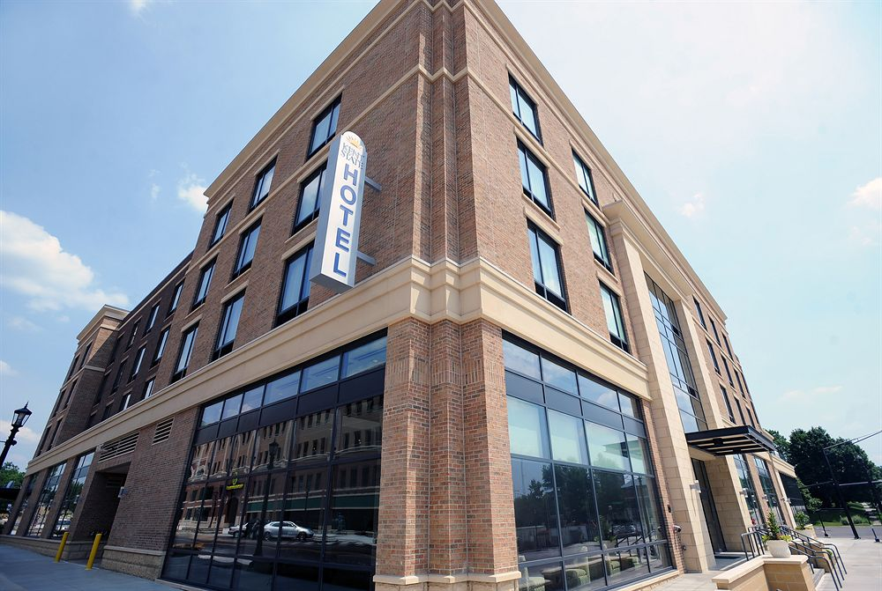

Top 2 [Hampton Inn Kent/Akron Area](http://www.tripadvisor.com/Hotel_Review-g50499-d101451-Reviews-Hampton_Inn_Kent_Akron_Area-Kent_Ohio.html)

4406 State Route 43, Kent, Ohio, 44240, USA TEL: +1-330-673-8555 FAX: +1-330-673-4455

website http://hamptoninn3.hilton.com/en/hotels/ohio/hampton-inn-kent-akron-area-CAKKTHX/index.html